Group 11 | Automated Aquaponic Garden PLC using a web-based interface
Major: | Team members:
CS | Chalmer M Frueauf
CS | Alexander John Gentry
CS | Derrick Kaliney
CS | Charles Witherspoon
Design Requirements
Objective 1: Device allows users to independently operate 8 different American style electrical sockets using a web app.
Objective 2: This device senses when the livestock tank water level is low and stops operations until water is added to the required level.
Objective 3: This device would host a webpage that allowed users to operate electric sockets on this device, run automated scheduling for lights, aeration, and water pumps set by the user.
Objective 4: This device would communicate with a database that would store growth data based on user input, log system modifications (i.e. when sockets were operational, water level notifications sent), and advises grow schedules based on plant types set by the user
Objective 5: This device would include a prototype aquaponic system. This aquaponic system is getting built as a component of this device to demonstrate functionality. The design uses a pipe system that would allow for up to 107 plants and would measure, allowing for up to 2” of variance, the following:
Grow bed structure:
Size: 48” * 72” * 36” (up to 2” of variation on this)
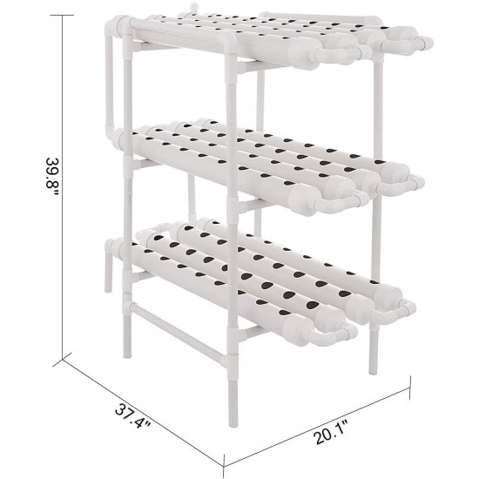
Illustrated in a single grow bed format below:
48””
36”
72”

Req No. | Obj No. | Requirement
10 | 1,2,3,4 | Device shall modify current flow independently on 8 electrical sockets via webpage interface. This operation is superseded by safety mechanisms to prevent unsafe operations, i.e. safety features could interrupt signals until safety measurements are met.
11 | 1,3 | The device shall host a webpage that provides controls to the onboard outlets.
12 | 1,3 | The webpage shall allow internal assignment of appliance types to individual outlets.
20 | 1,2,3 | Users can set a minimum water level that shuts down water pump operations during low levels as a safety measure.
21 | 2 | If the water does go below the minimum water level, a liquid tape measure sensor will sense it and shut down water pump operations.
22 | 2,3 | Users will get sent a notice when water levels are within range, that users are able to modify, of set minimum water level. (via email)
30 | 3 | The webpage shall be compatible with current mobile browsers.
31 | 3 | The webpage shall be compatible with current desktop browsers.
32 | 3 | The webpage shall meet coding standards of PHP.
33 | 3 | The webpage shall provide a dropdown of applicable, assignable types for each outlet.
34 | 3 | The webpage shall maintain persistent memory of assigned appliance types.
35 | 3 | The webpage shall allow the user to add and remove custom appliance types to the available list.
36 | 3 | The webpage shall allow the user to optionally set minimum and maximum tank water levels.
37 | 1,3 | The webpage shall allow for recurring daily scheduling of individual outlets.
38 | 1,3 | The webpage shall allow for scheduling of outlets based on appliance type.
39 | 1,3 | The webpage shall provide a menu for adding and modifying outlet schedules.
40 | 1,4 | The database shall be hosted on the raspberry Pi.
41 | 3,4 | The database shall store growth data.
42 | 3,4 | The database shall store system logs.
43 | 3,4 | The database shall store grow schedules.
44 | 3,4 | The system shall accept user input for growth data and only use data within tolerable ranges for that plant type.
45 | 1,3,4 | The webpage shall allow for scheduling to be done with the accuracy of whole minutes.
46 | 3,4 | The device shall maintain an accurate system time.
47 | 3,4 | The webpage, using login data on the database, shall provide unique access to the owner of the device.
48 | 1,3 | The device shall supply instructions for the user on acquiring and modifying webpage access, using and maintaining the prototype aquaponic system, and other instructions.
50 | 5 | Prototype system shall consist of multiple pipes grow beds with the measurements shown above. Variants of aquaponic system types such as ebb & flow and floating shall get demonstrated on this prototype system. Variance is allowable on up to 2” as long as system is watertight, other than water loss from evaporation, plant usage, and other “normal” aquaponic operations.
51 | 1,5 | ⁞Prototype system shall use multiple water-pumps, aeration devices, and lights to demonstrate the operation capabilities of the automated aquaponic plc device.
52 | 5 | Prototype system shall operate as a growth medium / environment for various fruit bearing and other types of vegetation, as well as different species of fish/shrimp depending on nitrogen load dependencies.
53 | 5 | Prototype system shall promote environments that are optimal for the species kept in the livestock water tank.
54 | 5 | Prototype system shall use livestock tank water to flow through the various grow beds to give the flora life nutrients.
55 | 5 | Prototype system shall get built using aquaponic practices and grow bed types.

⁞

Definitions:
Appliance- Any external device connected to this product by way of electrical cord for the purpose of being powered by this product.
Appliance Type- a user-defined specification of the purpose of an attached device. Types consist of, but are not limited to, lights, aerators, and water pumps.
Browser- External software intended for providing standard access to user-readable data from a server.
Tank- The aquarium or water-based system used in conjunction with the device. This is where the livestock is kept.

